COVER Page

CREATE A OIL AND GAS MONTAGE FOR THIS SPACE

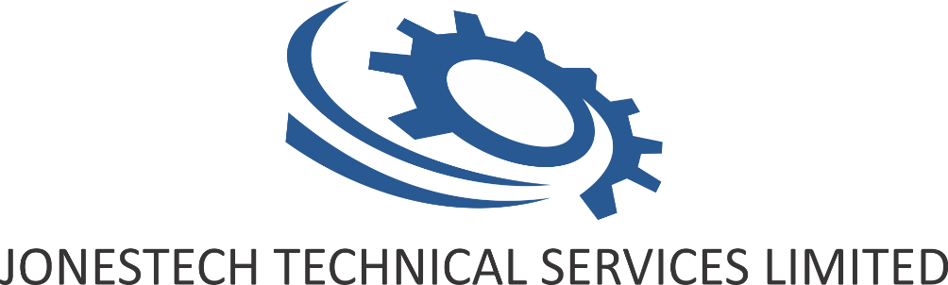

Office Address:

19 Baptist Mission Road Off Isaiah Road Ubeji,

Warri, Delta State,

Nigeria

Tel: +234 705 264 4119

+234 805 844 0348

Email: [Info@jonestechltd.com](mailto:Info@jonestechltd.com)

[sales@jonestechltd.com](mailto:sales@jonestechltd.com)

[johnson@jonetchltd.com](mailto:johnson@jonetchltd.com)

[jonestechltd@mail.com](mailto:jonestechltd@mail.com)

Web: www.jonestech.com

**CORPORATE PROFILE**

**WHO WE ARE**

JONESTECH Technical Services Limited is an indigenous company registered in Nigeria to carry out various forms of Procurement, Installation & Construction, Technical, Project management and Labor services in the oil and gas sector of the economy.

**OUR VISION**

To provide excellent technical services to our clients and partner companies

**OUR MISSION**

To be Quality driven in the execution of our projects and make Customer satisfaction the core of our business

**OUR CORE VALUES**

We affirm that commitment means faithfulness, Integrity, Safety, dedication, and loyalty to the cause of our services to our esteemed customers

**PROFESSIONALISM**

A drive to consistently perform more than the expectations of our customers and stakeholders, as well as in excess of the performance of peers. This will find expression in the areas including quality services, integrity, and accountability

**OUR SERVICES INCLUDES**

* Installation &Construction
* Testing Services
* Corrosion Control Services
* Supply of OEM Equipment
* Industrial Bore Hole and Water Treatment Plant Construction
* Fabrication
* Project Management
* HDD Services

**PIPING & PIPELINE INSTALLATION AND CONSTRUCTION**

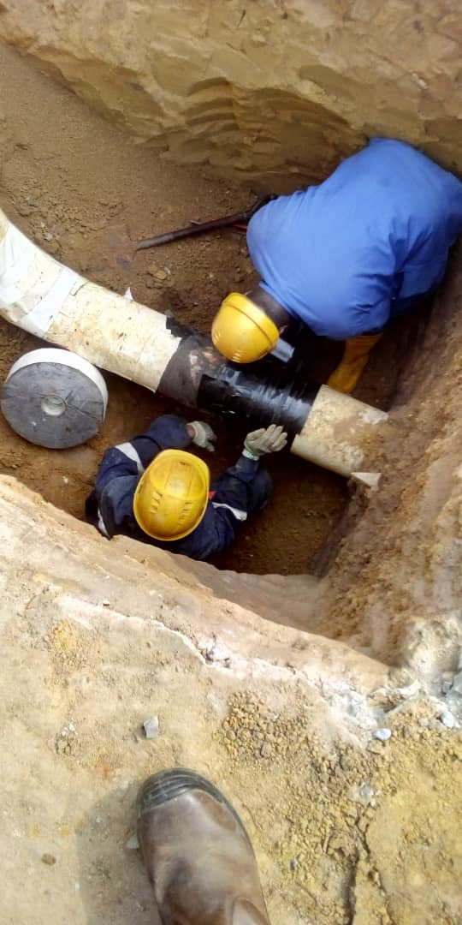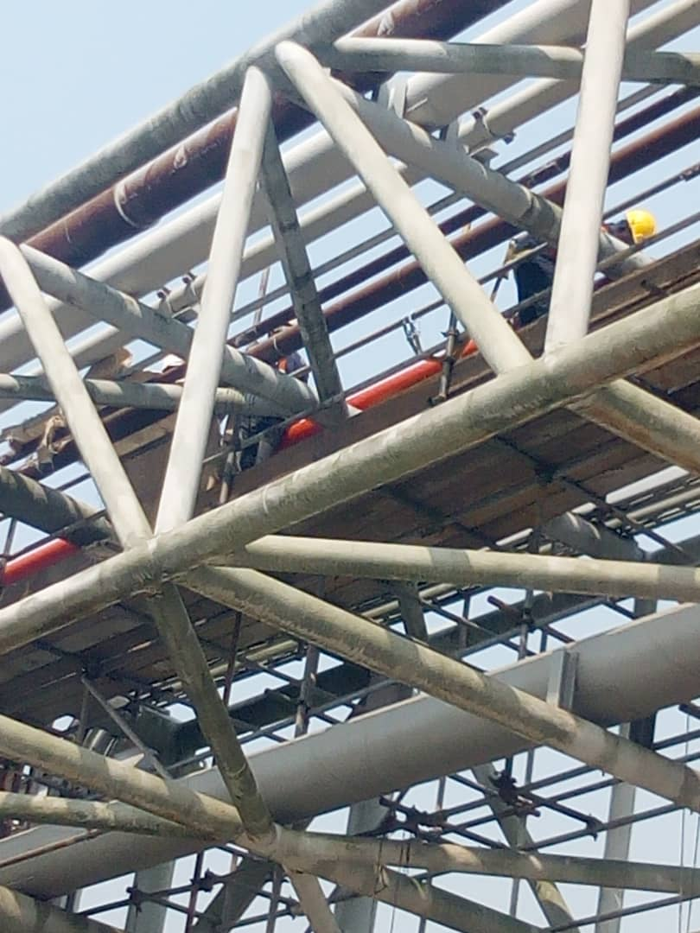

* Piping and pipeline Installation
* Mechanical and Facilities Installation
* Civil/Structural Construction
* Electrical/Instrumentation Installation

**TESTING SERVICES**

* Non-Destructive Testing Services
* Hydro testing Services
* Ultrasonic Testing Services
* X-ray/ Radiographic Test Services Shop & Site inspection Services

**CORROSION CONTROL SERVICES**

* Remediate and Reinforcement of Pipes
* Corrosion Barrier and Isolator
* Restoration of Pipes

**SUPPLY OF OEM EQUIPMENT**

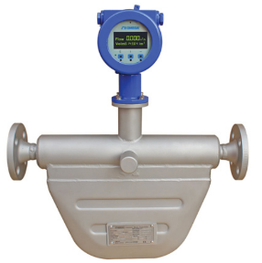

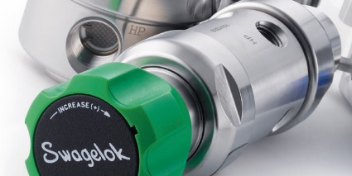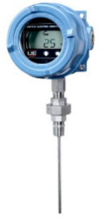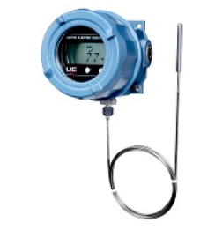

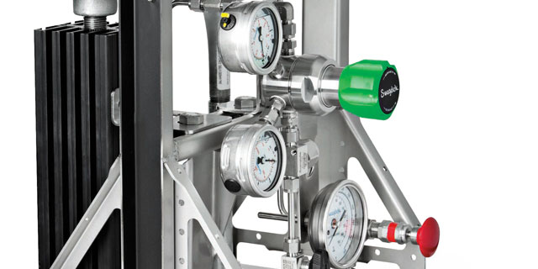

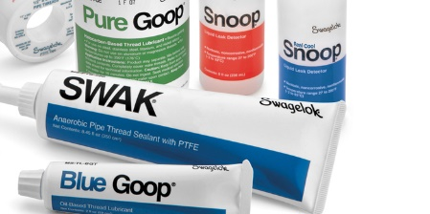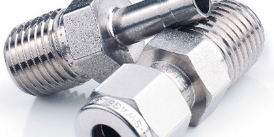

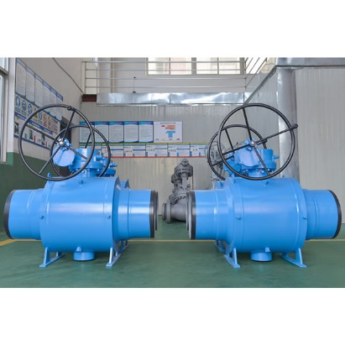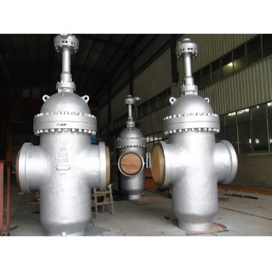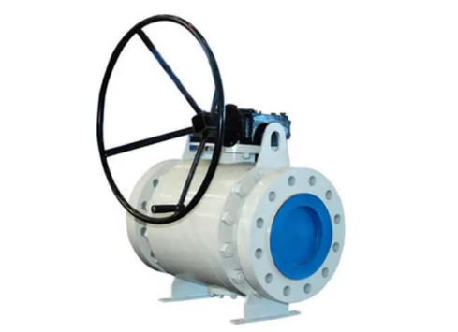

* Valves
* Fittings
* Measurement / Flow instrument
* Line Pipes and Induction Bends

**INDUSTRIAL BORE HOLE AND WATER TREATMENT PLANT CONSTRUCTION AND INSTALLATION**

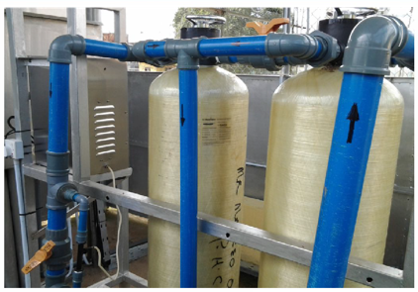

* Drilling of Borehole (4” to 12” diameter)
* Installation of Water treatment Plant
* Construction of Civil foundation
* Electrical installation
* Commissioning

**FABRICATION**

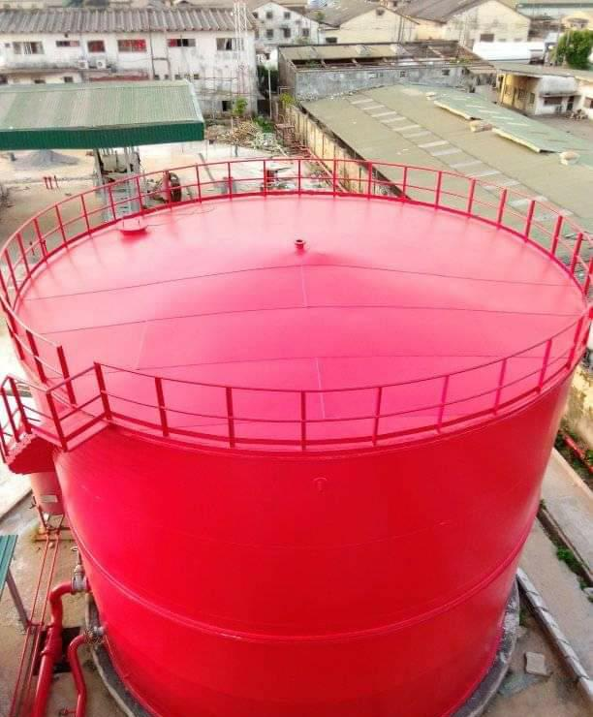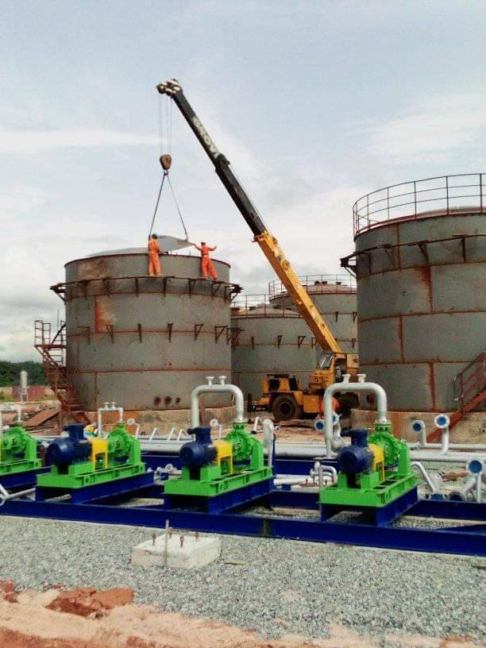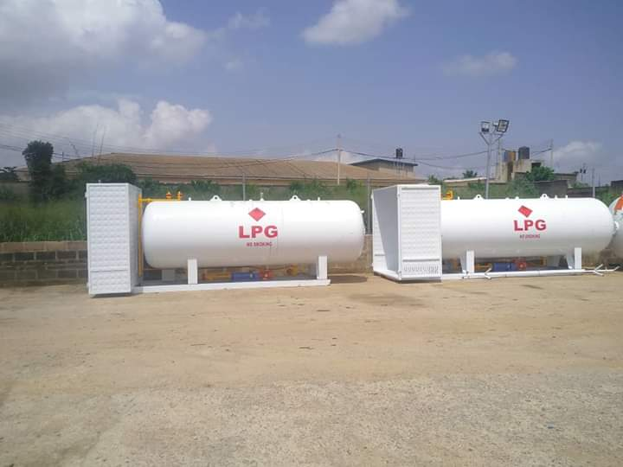

* Fabrication of Floating and Fixed Roof storage tanks
* Fabrication of ready to use LPG tanks and accessories
* Fabrication of Tank Base heating coil
* Fabrication of Piping Spools

**HORIZONTAL DIRECTIONAL DRILLIN SERVICES**

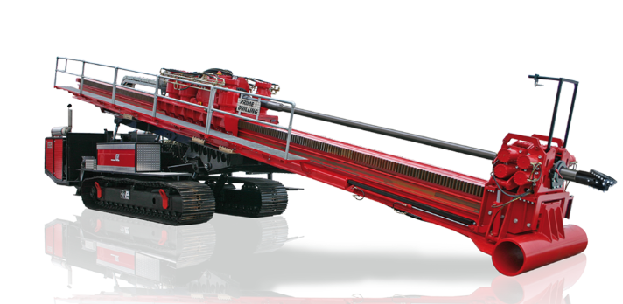

* HDD Rig and Accessories Lease and Supply
* Road and River crossings
* Continuous Horizontal Directional Drilling techniques
* Supply of Drilling mud and additives
* Supply of Drilling Consumables
* Supply of experienced HDD Local Support staff

**PROJECT MANAGEMENT**

* PMT
* Project support
* Project planning and Scheduling
* Community Engagement
* Procurement

**PARTNERS**



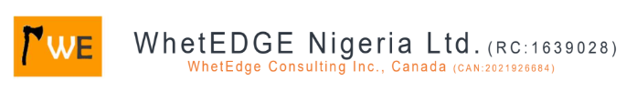



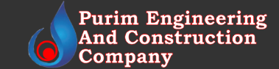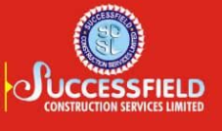 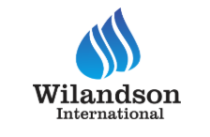

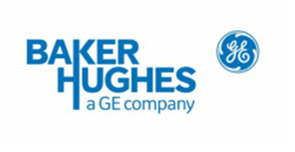OEM PARTNERS

Manufacturers of Instrument controllers, Control valves (LCV, PCV &TCV), positioners, Ultrasonic meters & LACT unit, Well head solution (Surface and down hole equipment), Eddy Current Equipment, Ultrasonic Portable equipment, Radiography & CT equipment, Remote Visual inspection equipment, e.t.c

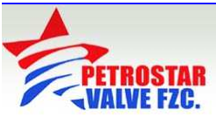Manufacturers of Manual valves of different type/sizes (gate valve, plug valve, Globe valve, check valve &ball valve).

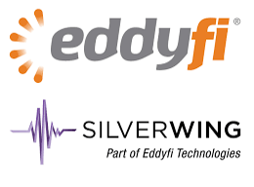Magnetic flux leakage (MFL); Scorpion B-Scan; Rapid Motion; Scanner (RMS 450); Pipe Scan; Vacuum Box; Long Range UT (LRUT).

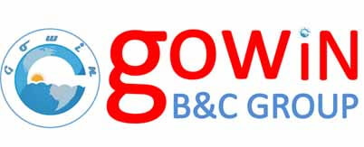

Gowin Group specializes in valves and related flows control equipment.